Ryan G. Cooper

Professor Conlan

CS-405 Module 2 Assignment Two

May 19th, 2024

**Securing Code from SQL Injection**

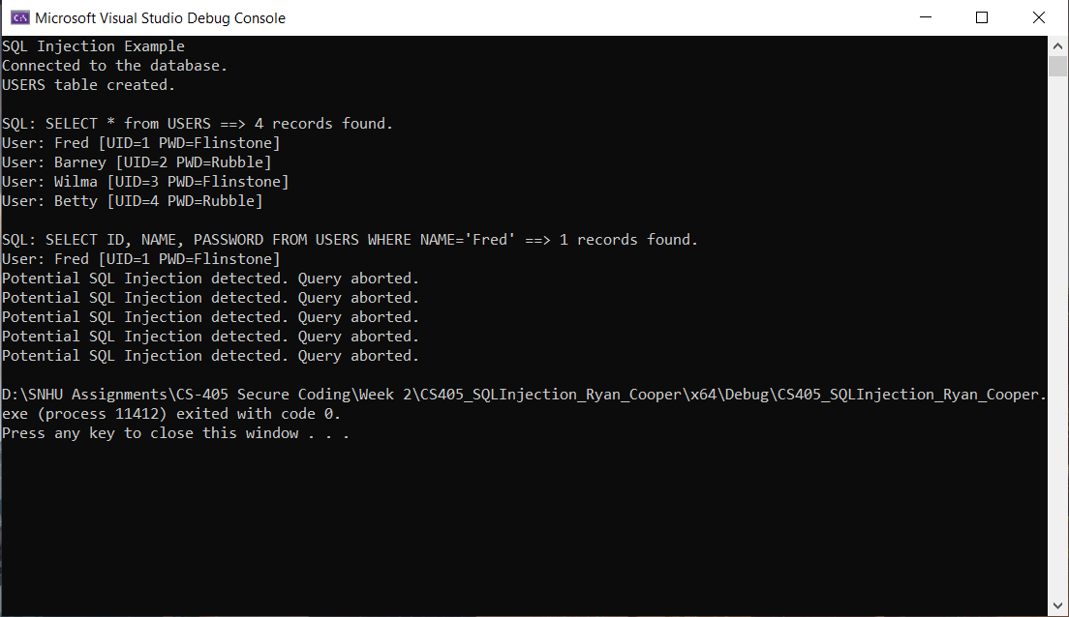

The above screenshot shows the output of the SQL injection code. To defend against these SQL injections, I have used regular expression searching to look through the user input and find matching strings that could be used for an injection. For this to work I first had to make a list of common characters that are used in SQL injections. Then an if statement checks whether the user input has an SQL injection within it. This method does work and passed all the tests, as seen in the screenshot.